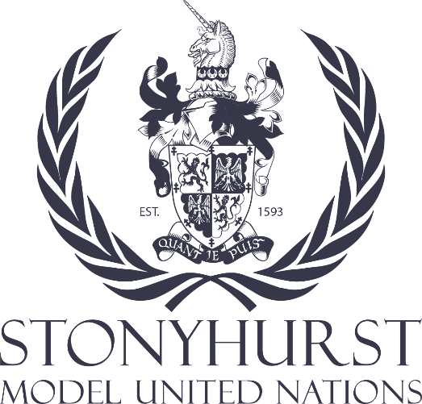
2. Briefing Paper – Health Committee
Topic: The issue of Vaccine Equity and Distribution– addressing issues related to equitable access to vaccines, including distribution, intellectual property rights, and affordability
Background information
Immunization is a global health and development success story, saving millions of lives every year. Vaccines reduce the risks of getting a disease by working with your body’s natural defences to build protection. We now have vaccines to prevent more than 20 life-threatening diseases, helping people of all ages live longer, healthier lives. Immunization currently prevents 3.5-5 million deaths every year from diseases like diphtheria, tetanus, pertussis, influenza and measles. Vaccines are also critical to the prevention and control of infectious disease outbreaks. They underpin global health security and will be a vital tool in the battle against antimicrobial resistance.
The COVID-19 pandemic, associated disruptions, and COVID-19 vaccination efforts strained health systems in 2020 and 2021, resulting in dramatic setbacks. However, from a global perspective recovery is on the horizon- in 2022 diphtheria-pertussis-tetanus (DTP) immunization coverage, albeit unevenly between countries, has almost recovered to 2019 levels.
Vaccine Inequity: The global vaccination landscape remains unequal, with lower-income countries facing considerable challenges in securing vaccines. This disparity poses a security risk by perpetuating the pandemic.
Intellectual Property Rights: Intellectual property rights, including patents, have emerged as a significant barrier to equitable vaccine distribution. Their impact on global security is profound, as unchecked outbreaks anywhere can affect everyone.
The Trade-Related Aspects of Intellectual Property Rights (TRIPS) waiver proposal at the World Trade Organization (WTO) aims to temporarily suspend certain intellectual property rights related to COVID-19 vaccines, facilitating greater access.
Affordability: The cost of vaccines and their distribution can be prohibitive for some countries, exacerbating the security threat of the pandemic. Lower-income countries often struggle to allocate resources for vaccination campaigns, risking the perpetuation of the virus and potential mutations.
Sources and further information:
trips_report_e.pdf (wto.org)
https://www.fiercepharma.com/pharma/pfizer-expands-program-will-provide-all-its-products-cost-poor-countries
COVAX Facility (gavi.org)
COVID-19 - The Global Fund to Fight AIDS, Tuberculosis and Malaria
Vaccine access, equity and justice: COVID-19 vaccines and vaccination - PMC (nih.gov)
WTO | A new commitment for vaccine equity and defeating the pandemic

