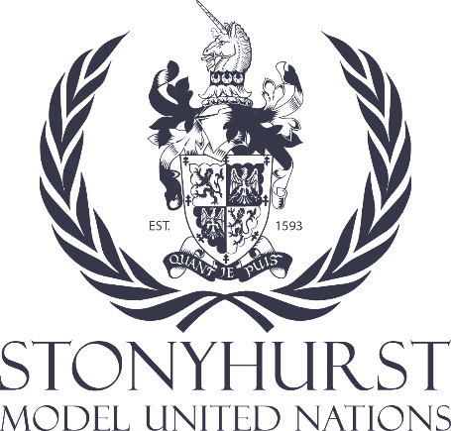
Model United Nations Resolution

The issue of humanitarian impact of global conflict
Ethics Committee: Stonyhurst MUN
Chair: Thomas Ketchen
Co-Chair: Hannah Crawley

Introduction:

Recent global events have underscored the urgency and complexity surrounding foreign interventions. Ongoing situations such as the humanitarian crisis in Syria, the aftermath of Afghanistan's withdrawal, escalating tensions in Ukraine, and various other instances worldwide have reignited discussions on the ethical dimensions of foreign interventions. These events have sparked extensive debates, raising crucial questions regarding the moral, legal, and humanitarian implications of interventions on national sovereignty, human rights, and regional stability. Delegates should consider the topic surrounding the humanitarian crisis in Syria and the geopolitical intervention/involvement of other nations.

The United Nations Ethics Committee is convened to address the ethical dimensions of global conflicts, focusing on human rights violations and the impact of interventions on civilians. This necessitates an exploration of countries’ international legal obligations and an examination of the ethical principles guiding international responses, such as the responsibility to protect.

The role of international organisations, particularly the United Nations, is pivotal in responding to human rights violations. Ethical challenges faced by these bodies in enforcing human rights standards and holding perpetrators accountable are central concerns. Shifting focus to the impact of interventions on civilians, a nuanced analysis of consequences, including displacement and access to basic needs, underscores the ethical obligations of interveners. Additionally, the psychosocial impact on vulnerable groups and the ethical responsibility in post-conflict reconstruction demand careful consideration.

In conclusion, this briefing paper provides insight into the ethical complexities of global conflicts. Delegates are urged to consider the legal and ethical framework, the role of international organisations, and the impact on civilians as they deliberate on ethical guidelines and recommendations within the United Nations framework.

Points to Consider:

1. The Balance of Sovereignty and Humanitarian Responsibility: Ensuring that interventions prioritize the protection of human rights while respecting the sovereignty of nations.

2. Role of International Law: Emphasizing compliance with international law and norms in all interventions, preventing violations and ensuring accountability.

3. Long-term Implications: Considering the long-term socio-political and economic impacts of interventions on affected regions and populations.

4. Exit Strategies and Post-Intervention Plans: Formulating clear exit strategies and robust plans for post-intervention nation-building and support programs to ensure stability.

Further Points to Consider:

1. Collaboration and Diplomacy: Promoting dialogue, collaboration, and diplomacy as primary means to address conflicts before resorting to interventions.

2. Humanitarian Aid and Protection: Ensuring the provision of humanitarian aid and protection to affected populations regardless of the decision to intervene militarily.

3. Ethical Evaluation Mechanisms: Establishing transparent mechanisms for evaluating the ethical justifications and consequences of interventions.

