Stonyhurst College
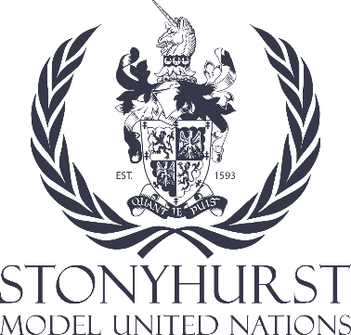
Stonyhurst College MUN conference
Human Rights Council
Chair: Matilda Weskamp
Co-Chair: Hannah Karschti

Subject: Women's Rights

I. Introduction

The topic of women's rights, abortion rights, education rights, and voting rights is a critical issue facing the global community, and it falls within the purview of the Human Rights Council. Women's reproductive rights, education rights, and the right to vote are integral to their overall human rights, encompassing health, education, political participation, and gender equality.

II. Background

1. International Agreements and Declarations
- The Universal Declaration of Human Rights (UDHR) affirms the principle of non-discrimination based on gender and emphasizes the right to life, liberty, and security of a person.
- The Convention on the Elimination of All Forms of Discrimination Against Women (CEDAW) explicitly recognizes women's rights to make decisions regarding their own bodies, participate in education, and vote.
- The International Conference on Population and Development (ICPD) in 1994 recognized the importance of sexual and reproductive health and rights.

2. Abortion Rights Around the World
- Abortion laws and regulations vary widely, from countries where it is fully legal to those where it is prohibited in most cases.
- Access to safe and legal abortion is a critical determinant of women's health and well-being.

III. Key Issues and Concerns

1. Reproductive Health and Maternal Mortality
- Unsafe abortion contributes to maternal mortality and morbidity.
- Access to safe and legal abortion is essential for reducing these health risks.

2. Gender-Based Violence, Discrimination, and Education Rights
- Restrictive abortion laws can perpetuate gender-based violence by denying women control over their bodies.
- They also reinforce harmful gender stereotypes and discrimination.
- Comprehensive sexual education is essential in promoting reproductive health and rights and reducing gender-based violence.

3. Women's Rights and the Right to Vote
- Ensuring equal voting rights for women is essential for achieving gender equality and representation in decision-making processes.
- Encouraging equal and unrestricted access to voting is an integral part of the broader fight for gender equality and human rights.

IV. National Sovereignty vs. International Standards

1. Balancing National Sovereignty and Human Rights
- Nations often argue for the right to determine their own abortion laws, citing cultural and religious reasons.
- At the same time, international human rights standards set expectations for gender equality, reproductive rights, education, and voting.

V. Possible Solutions and Recommendations

1. Promoting Comprehensive Sexual Education, and Abortion Rights
- Encourage member states to implement comprehensive sexual education programs that inform and empower individuals, addressing the importance of abortion rights within the broader context of reproductive health.

2. Supporting Access to Safe and Legal Abortion
- Advocate for the removal of restrictive abortion laws and access to safe, legal, and affordable abortion services, emphasizing the importance of education in making informed choices.

3. International Monitoring and Reporting
- Suggest creating mechanisms to monitor and report on women's rights, including abortion, their right to vote and access to education systems, holding nations accountable to international agreements or placing sactions if those agreements are not followed.

VI. Conclusion

The issue of women's rights internationally is a complex and sensitive topic, but integral to the broader fight for human rights. As delegates in the Human Rights Council, it is your responsibility to engage in thoughtful and respectful dialogue to find solutions that respect national sovereignty while upholding and improve international human rights standards.

References
- https://www.un.org/en/about-us/universal-declaration-of-human-rights
- https://www.ohchr.org/sites/default/files/Documents/ProfessionalInterest/cedaw.pdf
- https://www.unfpa.org/events/international-conference-population-and-development-icpd#:~:text=International%20Conference%20on%20Population%20and%20Development%20(ICPD)
- https://www.who.int/health-topics/abortion#tab=tab_1
- https://www.pewresearch.org/short-reads/2020/10/05/key-facts-about-womens-suffrage-around-the-world-a-century-after-u-s-ratified-19th-amendment/
- https://www3.weforum.org/docs/WEF_GGGR_2022.pdf
- https://rm.coe.int/regional-study-on-women-s-political-representation-in-the-eastern-part/168070b6a4
- https://reproductiverights.org

